**Week 7 Deliverables**

**Group Name: Carpe-Diem group**

**Specialization: Data Science**

**Project Name: Bank Marketing (Campaign) -- Group Project**

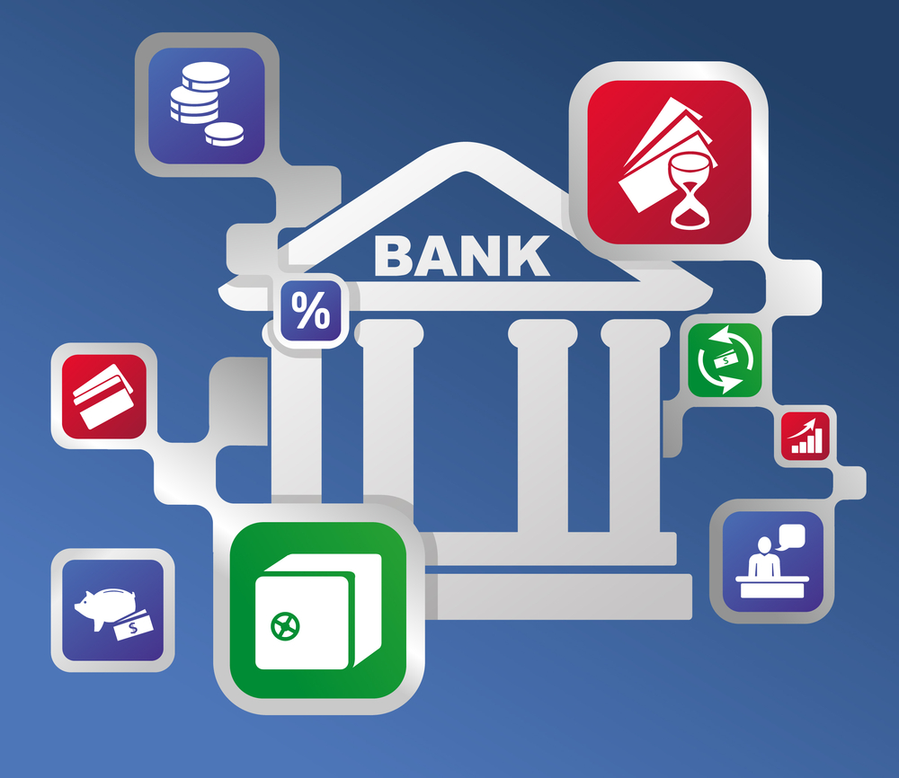

**Team Members:**

1. **Name**: Mohini Kalbandhe

* **Email**:amohini099@gmail.com
* **Country**: Canada
* **Company**: Happy Orchard
* **Specialization**: Data science

1. **Name**: Kashish Joshipura

* **Email**: kashishjoshipura@gmail.com
* **Country:** Canada
* **Collage**: The University of British Columbia (UBC)
* **Specialization**: Data Science

**Bank Marketing (Campaign)**

**Problem Statement:**

ABC Bank wants to sell its term deposit product to customers and before launching the product they want to develop a model which help them in understanding whether a particular customer will buy their product or not (based on customer's past interaction with bank or other Financial Institution).

**Problem description:**

One of the most common marketing strategy In Banking sector is direct marketing campaigns through phone calls ,it is a form of advertising that allows organizations to communicate directly with customers to offer their services based on the client’s existing bank profile .Here we will consider term deposit as a banking service .

**Business Goal :**

To build a list of target customers who are likely to subscribe a term deposit. The more targeted our campaigns, the more successful they are likely to be.

**Project Objective:**

By converting this problem into a machine learning classification problem we will build a model to predict whether a client will subscribe a term deposit or not so that the banks can arrange a better management of available resources by focusing on the potential customers “predicted” by the classifier .

**Technique to be used: Classification**

**Business Scope:**

● Forecasting the profit which the term deposit product brings.

● Analyzing customers interactions with ABC bank and other financial institutions.

● Use the outcome value (y/n) to track the number of customers who would subscribe to the term deposit product in order to predict its performance in the market.

● Analyze which customers would be more likely to buy the product. (eg. Married, divorced etc.)

● Help the ABC convey how the product ties with the customer’s benefits.

**Business understanding:**

* Portuguese Bank wants to improve marketing campaign to recommend which customer is to target by analyzing their past marketing data.
* The Motivation is by devising such prediction algorithm the bank can be a better target for its customer and better channelize its customer.
* Bank of Portugal offered its customer fixed term products such as CD’s. Data was collected about each client, type of contact and outcome.
* How does Predicting term deposit tie in with its mission and vision?
* How do the visual design and marketing copy of data help convey the Marketing success of this campaign?
* The Goal can be achieved by using ML algorithm will use customer records to predict future action to reduce company’s time and recourses.

**Project lifecycle along with deadline:**

Project lifecycle is a highfalutin way of describing the life of a project. Following are the high-level process of delivering a project and the steps to take a project and conduct a team from brief through to delivery.

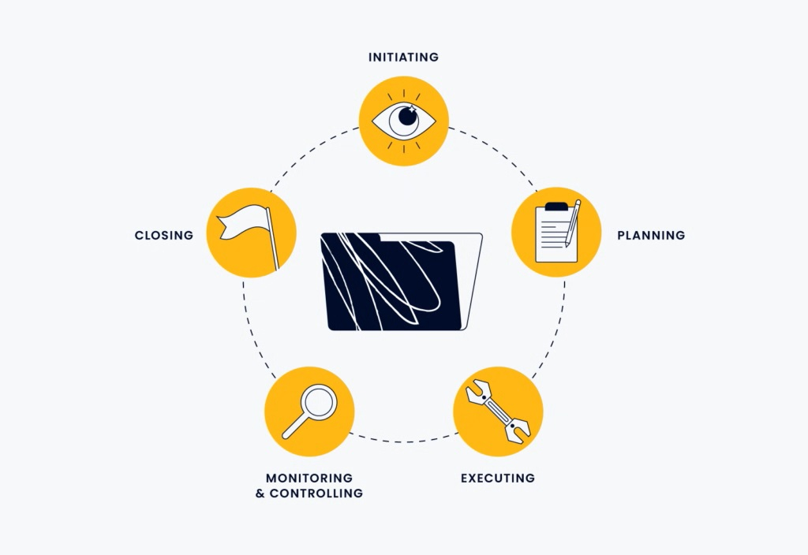

1. **Project Initiation:**

|  |  |
| --- | --- |
| **Tasks** | **Deadlines** |
| * Have a research and understanding on Bank business. * Problem statement, project goal and data variables understanding. * To provide business insights and solutions to issues in the data. | **Week 7 and 8:**  19th July 2022  26th July 2022 |

1. **Project Planning:**

|  |  |
| --- | --- |
| * Prepare data acquisition and data cleaning solution. * Create a python file with exploratory data analysis and power point presentation of the same. * Find the best solution and algorithm for data. | **Week 9, 10 and 11.**  2nd August 2022  9th August 2022  16th August 2022 |

1. **Project Execution:**

|  |  |
| --- | --- |
| * Try to apply different possible algorithms * Test the algorithm in different categories * Compare algorithms based on their performances. * Choose the best possible algorithm for model. | **Week 12:**  23rd August 2022 |

1. **Project Closure:**

|  |  |
| --- | --- |
| * With best possible algorithm create a final project model. * Create a power point presentation for final project. | **Week 13:**  30th August 2022 |

**Github Repo link:**

“https://github.com/amohini099/Banco-de-portugal-marketing”